Demand and Supply Questions
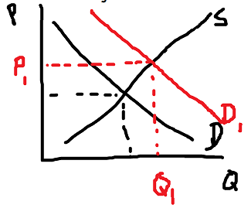
- The government gives a subsidy to producers of steel. Effect on the car industry?
- A health study shows the benefits of red wine. Effect on the beer market?
- A global pandemic makes it harder for people to attend movie theatres and live shows. Effect on the market for home video streaming services?
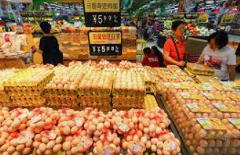
- A global shortage of computer chips makes laptops more expensive. Effect on the market for Microsoft Windows software?
- The global airline industry sees an increase in ticket sales. Effect on production of plastic goods such as kid’s toys?

Answers

1
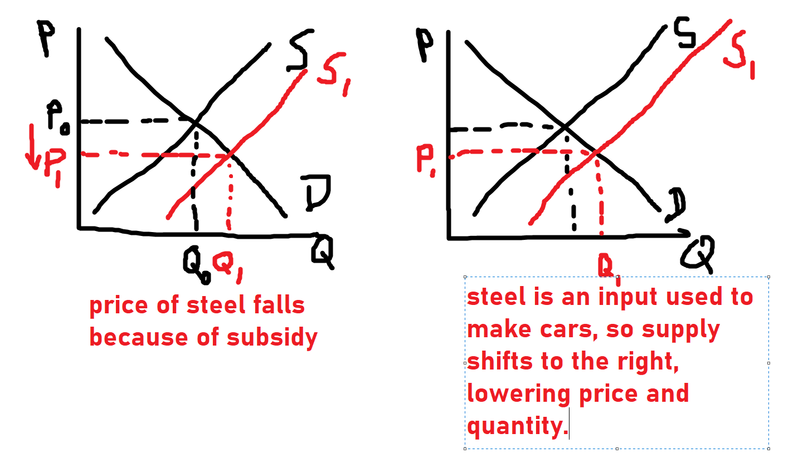

2
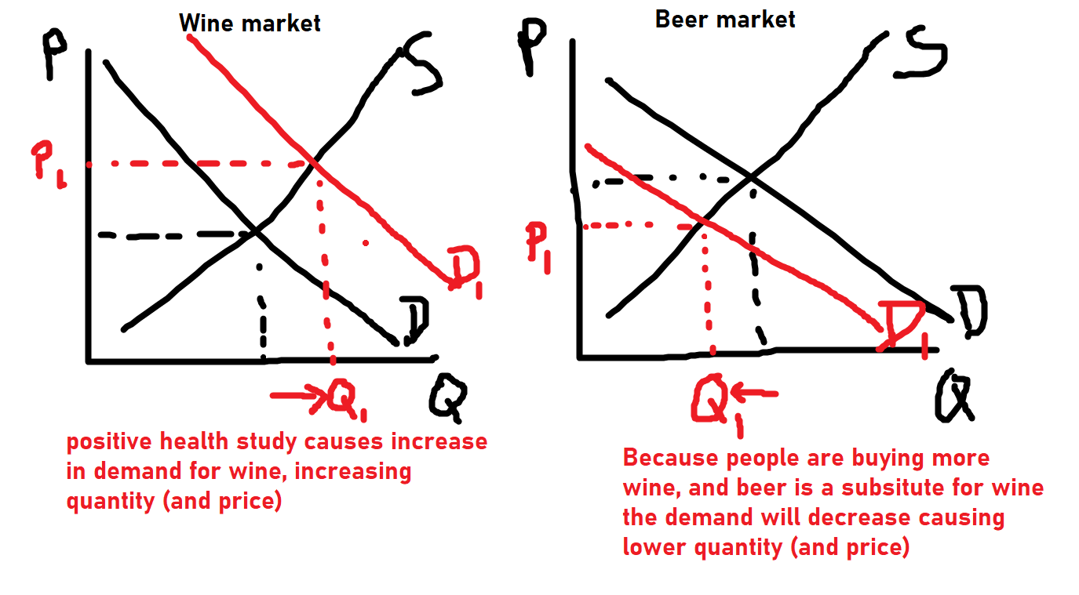

3
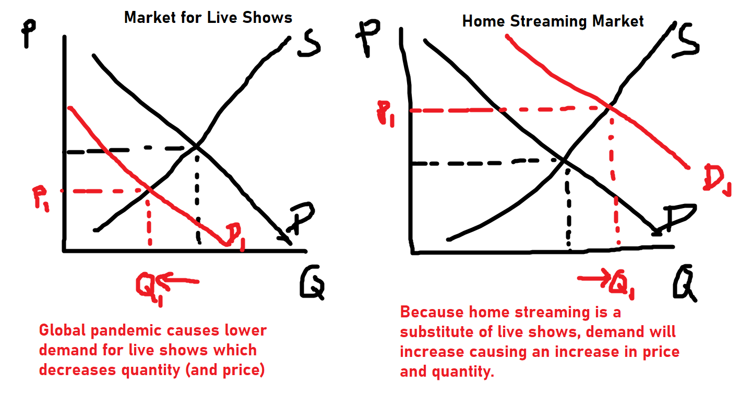

4
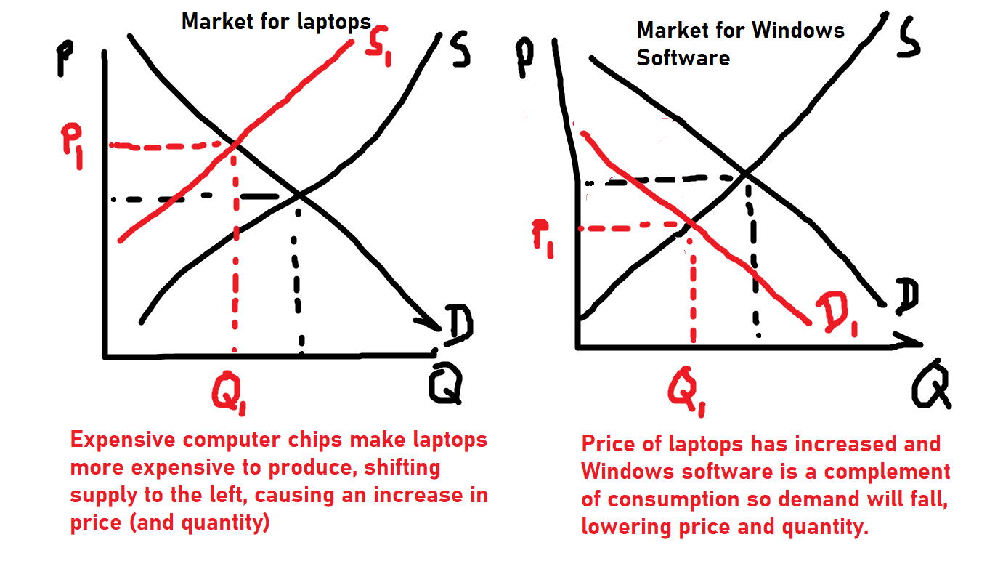

5
